HW03 REPORT

In this homework, I implemented a multilayer perceptron for multiclass discrimination in R.

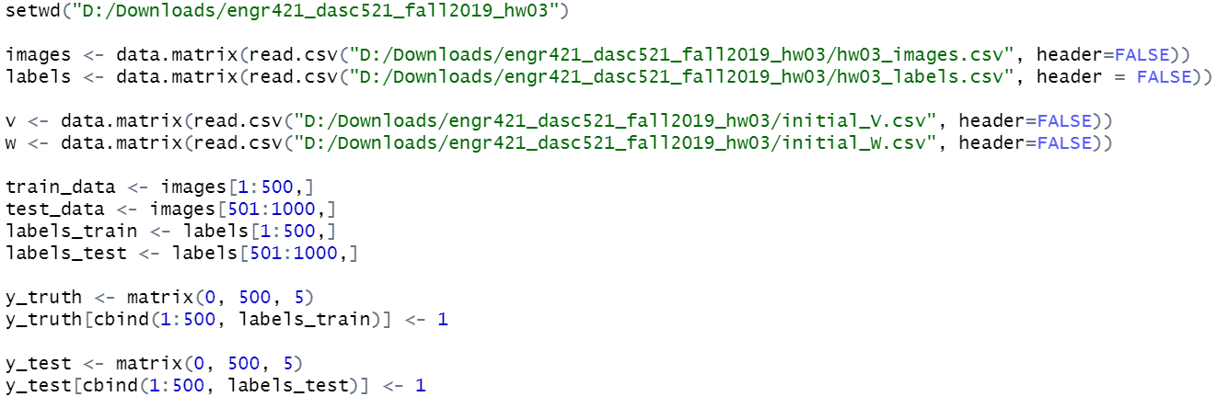As a first step, I read data, labels, v (21x5 matrix) and w (785x20 matrix) parameters. I split images dataset into train_data and test_data from the half which both are 500x784 matrix. Addition to this, I split labels dataset into labels_train and labels_test from the half which both are 500x1 vectors that correspond labels of the train_data and test_data respectively. I put labels to a matrix that show corresponding labels according to images. They are y_truth and y_test (both are 500x5 matrices) which correspond labels_train and labels_test respectively.

After that, I implemented softmax and sigmoid function to train a multilayer perceptron for multiclass discrimination using the sigmoid activation

function for twenty nodes in the hidden layer (𝐻 = 20) and using the softmax activation

function for five nodes in the output layer.

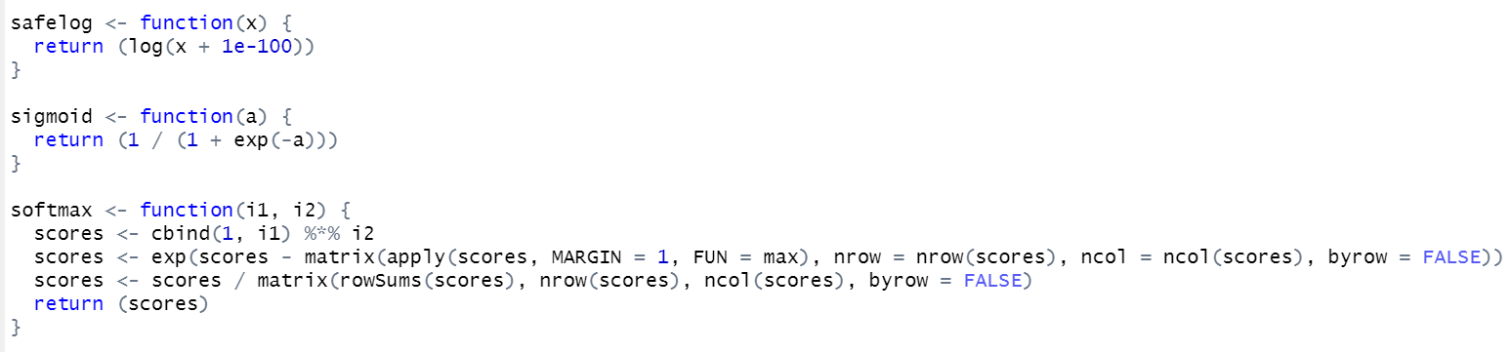

I set the H, eta, epsilon and max_iteration according to homework description pdf as below. I calculated z (500x20 matrix) using sigmoid function for twenty nodes in the hidden layer and y_predicted (500x5 matrix) using softmax function for five nodes in the output layer.

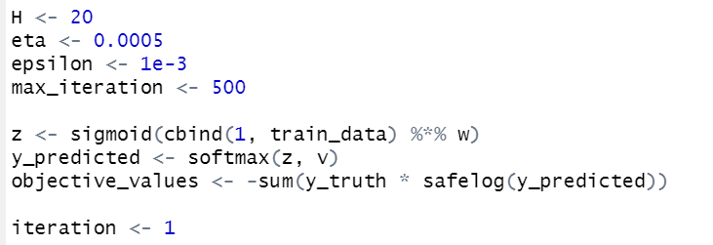

I developed a backpropagation algorithm under batch learning scenario with the following learning parameters. After reading chapter 11.7.3, I implemented batch learning part that is shown below.

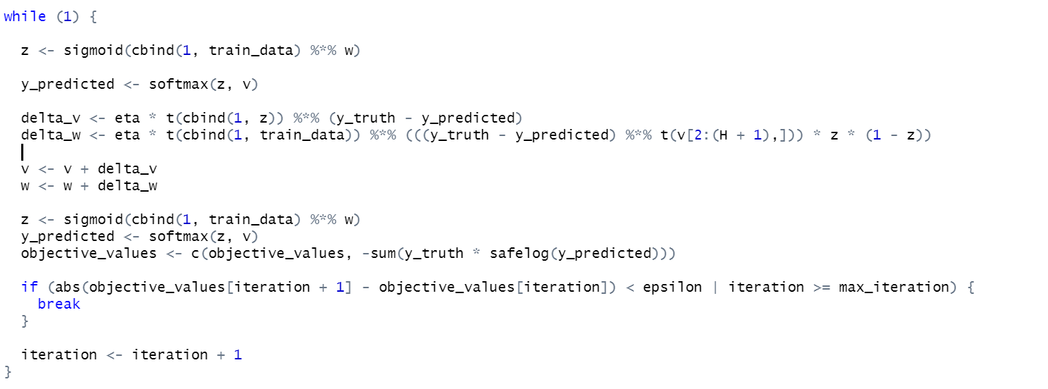

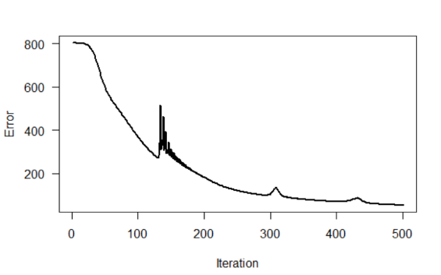After that, I plot the error function that is shown below.

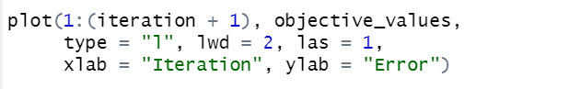

As a next step, I draw the confusion matrix for train_data’s predicted labels.

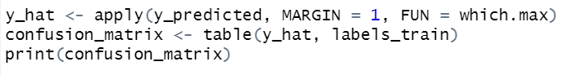

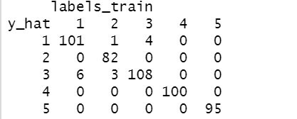

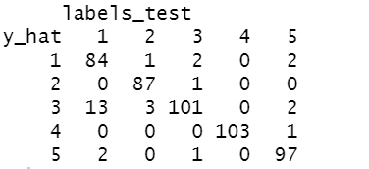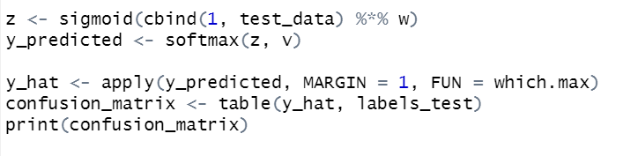As a final step, I calculated z (500x20 matrix) using sigmoid function for twenty nodes in the hidden layer and y_predicted (500x5 matrix) using softmax function for five nodes in the output layer using test_data and trained w and v parameters. Then, I draw the confusion matrix.